## **Running and visualising momentum based gradient descent**

Let’s look at the Python implementation of Momentum based Gradient Descent

1. Here is the Python code for Momentum Based Gradient Descent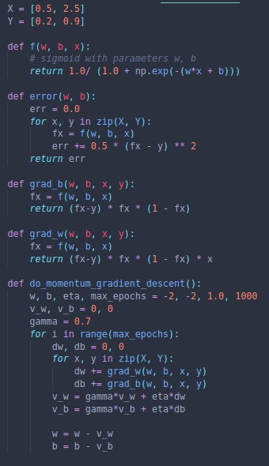
2. Now, let us compare the movement of Momentum based GD and regular GD

|  |  |
| --- | --- |
| **Gradient Descent** | **Momentum based Gradient Descent** |
|  |  |
| 40 epochs | 29 epochs |

1. However, there are still some issues with Momentum based GD that we will address in the next section